**Activities to Build ENGAGEMENT**

**Student Learning**

* **Parent Teacher Conferences**
* **Committee involvement including School Site Council, English Learner Advisory Committee, Parent Advisory Committee, and PBIS Tier I Team**
* **Partnership for Learning Network**
* **Math Meets**
* **Back to School Night and Success Fest**
* **Rallies for Academic Achievements**

**Social-Emotional Development and Growth**

* **PTSA Involvement**
* **Various Student Led Clubs**
* **Second Step Lessons**
* **MTSS-B counseling Lessons**
* **Chino Human Services**
* **Zen Den**
* **Talent Show**
* **Coffee with Counselors**
* **Student Recognition Breakfast**

**Volunteering Opportunities**

If you would like to volunteer, participate in, and/or observe a classroom, please contact your teacher. Observations must be cleared through the teacher and principal with at least 48-hour notice.

**Chino Valley Unified**

**School District**

**What is Home-School Partnerships?**

Home-School Partnerships is an agreement that parents/guardians, students, and teachers develop together. It explains how parents/guardians and teachers will work together to make sure all students reach or exceed grade-level standards.

Effective compacts:

* **Link** to goals of the school's single plan for student achievement
* **Focus** on student learning skills.
* **Describe** how teachers will help students develop those skills using high-quality curriculum and effective instruction in a supportive learning environment.
* **Share** strategies parents/guardians can use at home.
* **Explain** how teachers and parents/guardians will communicate about student progress.
* **Describe** opportunities for parents/guardians to volunteer, observe, and participate in the classroom.

**PARTNERSHIPS FAMILY/GUARDIAN PARTICIPATION**

**HOME-SCHOOL PARTNERSHIPS**

**for**

**STUDENT ACHIEVEMENT**

**2024-2025**

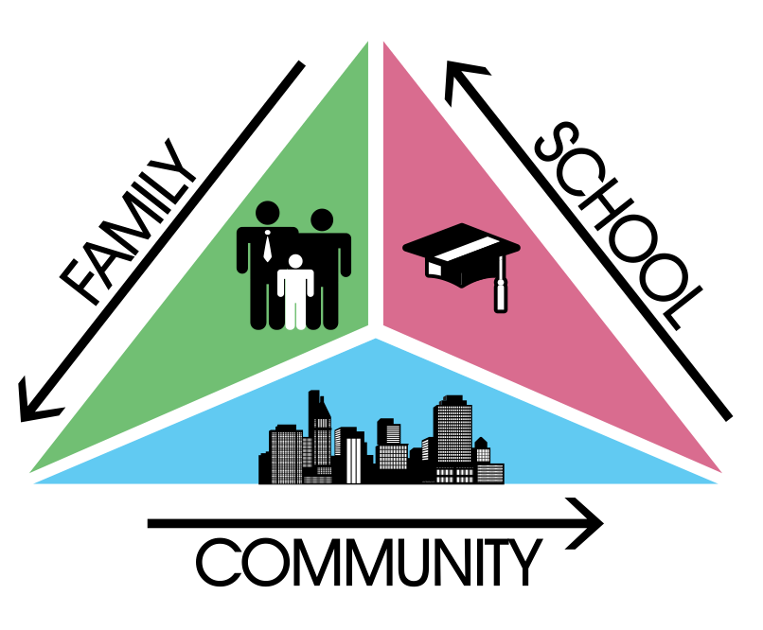

***Grade Seventh - Eighth***

***Always walk through life as if you have something new to learn and you will.***

***Vernon Howard***

**Canyon Hills Junior High**

*The World’s Greatest Junior High*

2500 Madrugada

Chino Hills, CA. 91709

909-464-9938

**Learning Compact**

**Communication about Student Learning**

Our school and families are committed to regular two-way communication about our children’s' learning. Some of the ways families and staff communicate all year are:

* **School to Home**
  + Phone calls/email
  + school website
  + school marquee
  + Weekly newsletter
  + Parent Square
  + School Agendas
* **Home to School**
  + Phone calls
  + email
  + parent-teacher meetings
  + Participate in activities to build partnerships

https://www.chino.k12.ca.us/canyonhills

**DISTRICT FAMILY RESOURCES**

**Family Engagement Center**

**Adult School, Room 25**

**12970 Third St. Chino, CA 91710**

**WORKSHOPS PROVIDED:**

***ENGLISH LEARNER PARENT ACADEMY***

***PARENTS AS PARTNERS***

***LEARNING TO READ***

***NURTURING PARENTS***

**SUPPORT WITH:**

***STUDENT ENROLLMENT***

***DATA CONFIRMATION***

***TECHNOLOGY***

***AERIES PARENT PORTAL***

**Family Engagement Center Link:**

**http://www.chino.k12.ca.us/Page/8882**

**909 628-1201 ext. 5601/5604 (English/Spanish)**

**(Chinese) 909 628-1201 ext. 5602**

**At Home**

**Here are some ideas of how families can support students’ success:**

· Utilize the AERIES Parent Portal to access your child’s grades, attendance, and behavior

· Contact teachers or counselor to maintain an open line of communication via email or phone.

· Be present! Establish time at home to discuss school, daily experiences, and positive interactions and take time to listen.

· Structure a routine for your child that fosters attention to completing homework, maintaining a healthy lifestyle, and attending daily.

· Check your child’s school work, agenda, Google Classroom, school supplies, and back pack routinely to establish an expectation of success.

· Attend school events, join decision-making committees, and participate in parent workshops. I will reinforce classroom learning by, upholding the school’s attendance and homework policies.

I will reinforce classroom learning by, upholding the school’s attendance and homework policies.

**In the Classroom**

**As a seventh/eighth grade teacher, I will engage all students with a vibrant learning climate and high-quality instruction. Listed below are some of the student learning strategies your child will use this year.**

**Academic Goals:**

* Engage students in Project Based Learning that is cross-curricular and incorporates technology
* Challenge students’ learning environment through STEAM activities
* Allow students to demonstrate their understanding through the use of informal/formal assessments, posters, and group presentations
* Foster a student’s individual potential and ensure students are well equipped for the world around them

**English Learner Goals:**

* Use structured, collaborative grouping configurations to develop ELA/literacy skills and cross-curricular standards
* Frontload Vocabulary
* Require students to annotate text
* Use manipulatives in Math
* Provide multiple opportunities to access information in a variety of ways.

**Activities students will do to support their learning:**

* Students will come prepared to learn, with necessary tools & seek help/guidance when needed, to further improve their academic success.
* Students will use 21st Century skills to organize, plan, and support learning to meet grade level expectations.

**Learning Compact**

**Teachers, Parents, Students Shared Responsibility for Learning**

**District Goals - Local Control Accountability Plan (LCAP)**

All students are provided a high-quality teaching and learning environment.

Staff, parents/guardians, families, and students are connected and engaged at their school to ensure student success.

All students are prepared for college and career beyond graduation.

**School Goals**

**Academic: Goal 1:** High-Quality Teaching and Learning Environment. This goal supports teachers and classified staff in the classroom including Professional Development training, materials for students, and release time. Allocation includes, Professional Development of Choice, Release days for PLC Planning, and Classroom Supplies.

**Non-Academic: Goal 2:** Connections to and Engagement at School ensure student success. This supports parent involvement, school climate, and students feeling safe in school. This is accomplished by workshops for parents, assemblies, MTSS-B/PBIS implementation, bilingual clerk (community liaison), and second step lesson completion.

**English Learner: Goal 3:** Preparation for College and Career. This goal supports all students but focuses on EL and SPED intervention, which includes, an Intervention teacher, STEP meetings, specific materials, and Professional Development.

*Our school provides high quality curriculum and instruction in supportive and effective classroom environments to enable students to meet state academic standards. We support our students and work hard to provide a welcoming, safe school environment.*

**Our Goals for**

**Student Achievement**